**Oracle Database Administration Service**

**Statspack Installation for Performance Monitoring**

Submitted to



**By**



CIS, Wipro Limited

Document Details

|  |  |
| --- | --- |
| Project Name | Innogy |
| Account | CIS |
| IT Component/Application Title | Statspack Installation for Performance Monitoring |
| Current Version | 1.1 |
| List of Contributors | Jiten Pansara |
| Customer Contact Information |  |

Version History

(All revisions made to this document must be listed in chronological order. All revisions must be approved. Review and Approval can be done by an internal source or by the customer)

|  |  |  |  |  |  |
| --- | --- | --- | --- | --- | --- |
| Version | Date of Revision | Description | Author | Reviewed By | Approved By |
| 1.0 | 12-03-2019 | Initial Draft | Jiten Pansara | Ajay Zende | Santosh Badiger |
| 1.1 | 21-03-2019 | Document Completed | Jiten Pansara | Ajay Zende | Santosh Badiger |

Document Distribution List

|  |  |  |
| --- | --- | --- |
| **Sl. No.** | **Name and Company** | **Purpose** |
| 1 | RWEIT-ORACLEDBA | **This document is used to install Statspack to monitor database performance.** |
| 2 |  |  |

**TABLE OF CONTENTS**

1. Purpose 5

2. Scope 5

3. Steps to Install Statspack 5

1. **Purpose**

This document is prepared for Statspack installation procedure so that we can analyze performance issues without Diagnostic and Tuning packs.

|:dg&hx ja)Mz0

1. **Scope**

This document is prepared for Innogy UK Wipro sustenance team and provides the insight procedure regarding installation of Statspack.

1. **Steps to Install Statspack**
2. First create tablespace to hold data of Statspack.

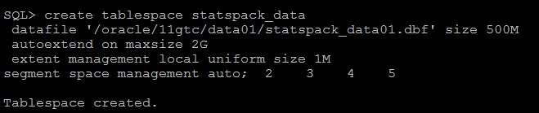

1. There is one file available to create Statspack which will take two parameters. Default Tablespace can be any tablespace name in which you want to store the data, in our case, we have created SNAPSHOT_DATA so we have used that only and temporary tablespace as “TEMP”.

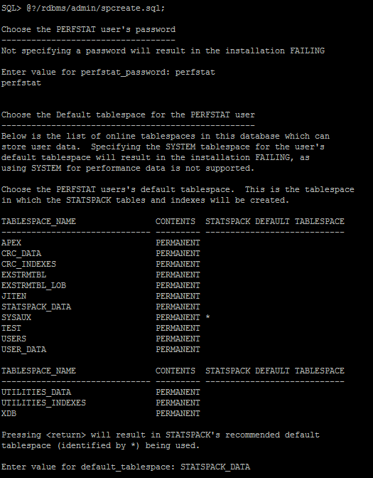

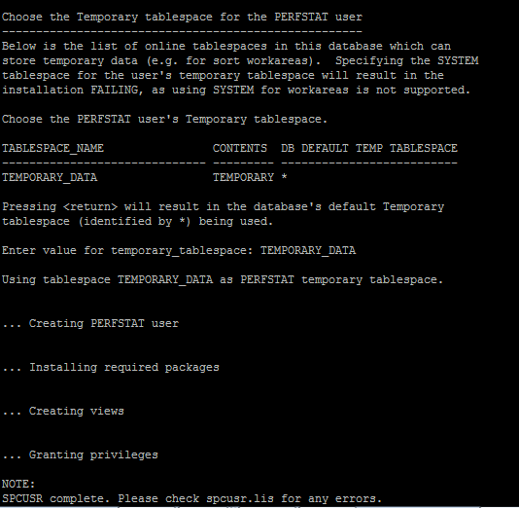

1. After installation, we need to create SNAP’s which can be created as below.

EXEC Statspack.snap;

1. Once it is done,

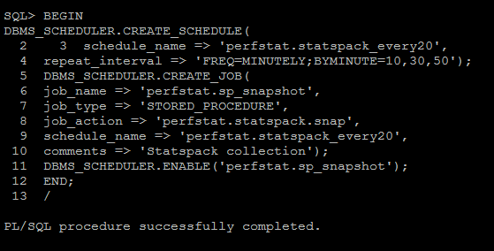

You might face below error:

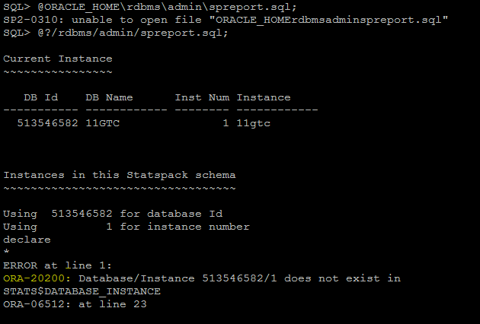

1. To resolve that issue, we need to create a Snap manually as mentioned below.
2. Once it is done, run spreport.sql which will work same as AWR report and gives output in screen.

